MUJTABA SHAHID FAIZI

BSCS-5A

131818

COMPUTER NETWORKS LAB 1

#import hello this is not a lib in python

import time # time lib in python

import sys

#output comment

print("Hello World"); #parenthesess are for newer versions

print "Hello World";

print "Hello World" #statements can be terminated without ";" but need new line for difference

print "Hello World"

print "Hello World";

print "How are u";

#Variables

x=10;

print x;

print x**2; #10 square

x="Hello"

print x; #printing string

#Strings

str = "Hello World!"

print str # Prints complete string

print str[0] # Prints first character of the string

print str[2:5] # Prints characters starting from 3rd to 5th

print str[2:] # Prints string starting from 3rd character

print str * 2 # Prints string two times

print str + "TEST" # Prints concatenated string

#Always string returned in raw_input (input since 3.0)

y=raw_input("Pl enter any value: ");

print y;

print 5*y # printed 5 y times

print 5*int(y) # multiplied 5 with y

#Command line arguments

#print 'Number of arguments:', len(sys.argv), 'arguments.'

#print 'Argument List:', str(sys.argv)

#With the len(sys.argv) function you can count the number of arguments.

print (sys.argv[0]) #sys.argv[0] is the name of the script

#Lists vs Tuple Vs Dictionary

#list

list1 = [ 'abcd', 786 , 2.23, 'john', 70.2 ]

print list1 # Prints complete list

print list1[0] # Prints first element of the list

print list1[1:3] # Prints elements starting from 2nd till 3d

print list1[2:] # Prints elements starting from 3rd element

list1[2] = 1000 # Valid syntax with list

print list1

#Tuple

list2 = ( 'abcd', 786 , 2.23, 'john', 70.2 )

#list2[2] 1000 # In-valid syntax with tuple

#Dict

list3 = {'EmpName': 'Ahmed','EmpCode':6734, 'Dept': 'sales'}

print list3['EmpName'] # Prints value for 'one' key

print list3['Dept'] # Prints value for 2 key

print list3 # Prints complete dictionary

print list3.keys() # Prints all the keys

print list3.values() # Prints all the values

#Decisions

x=10

y=20

if (x<11):

print 'value of x is: ',x

print 'value of x is: ',x

elif (y<11):

print 'value of y is: ',y

else:

print "None is true"

#Loops

x=10

while(x>5):

print x

x=x-1

y=[1, 2, 5]

#for Loop

for x in y : #printing the values of array/list y

print x

list=['Hello', 1, 2, "End"]

for x in list:

print x

#Functions

def myfunction(*arg):

print arg

for n in arg:

print int(n)

return;

myfunction(10,20,30)

myfunction(40)

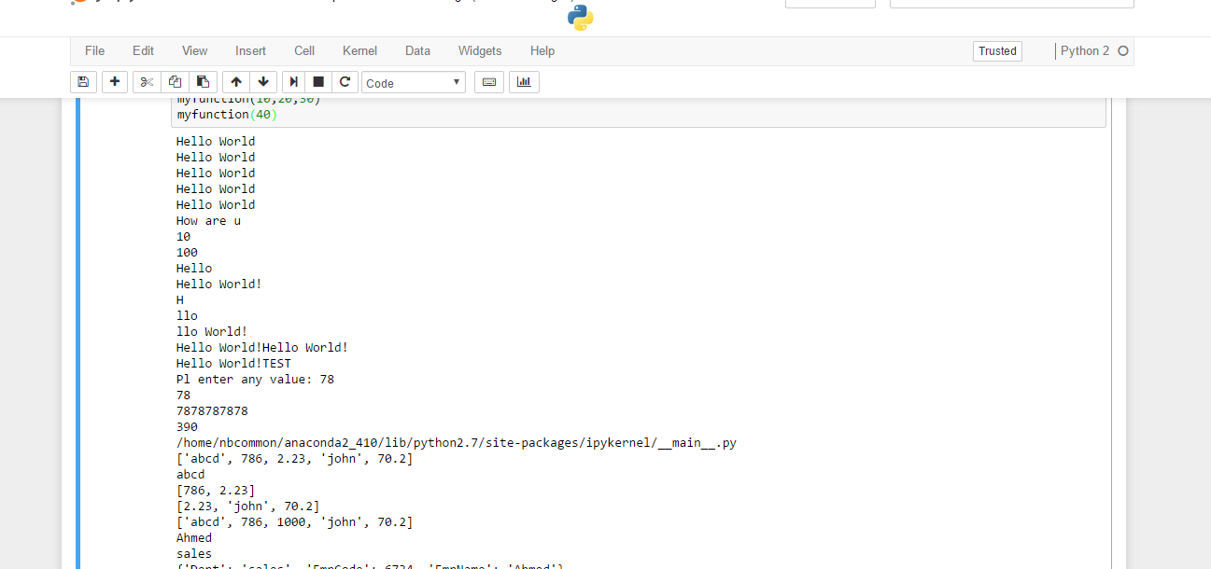

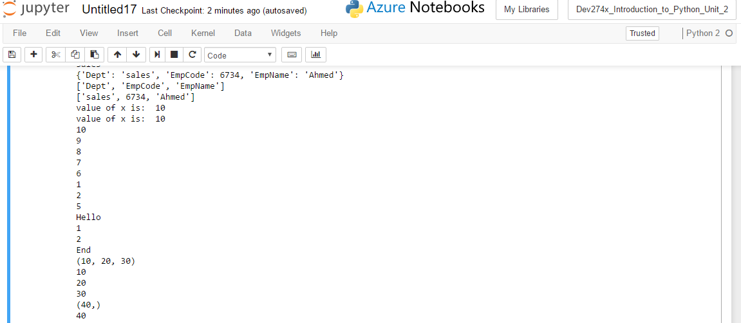

myFile=open("hello.py",'w')

myFile.write("Hows it going??")

myFile.close()

fileread=open("hello.py","r")

data=fileread.read()

print (data)

fileread.close()

print " Current time: ", time.asctime(time.localtime(time.time()))

print sys.path

